Multiple-choice section

|  |  |  |  |  |  |  |
| --- | --- | --- | --- | --- | --- | --- |
| Question | 1 | 2 | 3 | 4 | 5 | 6 |
| Answer | A | B | C | C | D | C |

Question 1 [7.1]

A

Mark the letters O, A and H on the diagram.

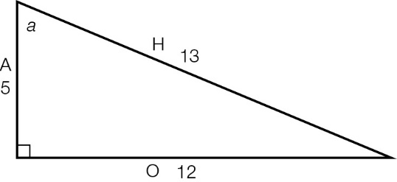



Question 2 [7.2]

B

Mark the letters O, A and H on the diagram.

|  |  |
| --- | --- |
| ACPM9_PR_7_02wsf | sin(θ) ==  =  *x* = × 25  *x* = 5 |

Question 3 [7.3]

C

Mark the letters O, A and H on the diagram.

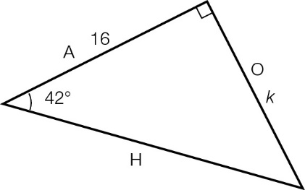

O and A can be used with the tan ratio: tan(42°) =

Question 4 [7.4]

C

Mark the letters O, A and H on the diagram.

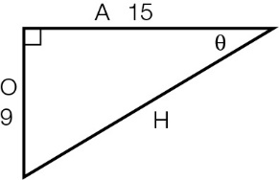

O and A can be used with the tan ratio: tan(θ) =

Question 5 [7.5]

D

|  |  |
| --- | --- |
| ACPM9_PR_7_05wsf_RR | tan(49°) = , so *s* =  *s* = 8.3 m |

Question 6 [7.5]

C

138°T is between E (90°) and S (180°). It is 42°E of S (180° − 38° = 42°), so it’s written as S42°E.

Multiple-choice total marks: 6

Short answer section

Question 7 3 marks [7.5]

cos(θ) =

Length of adjacent side = 3.2 m

cos(θ) = 

Given cos(θ) = :



4*x* = 16

*x* = 4 m

Question 8 3 marks [7.5]

tan(θ) = 

tan(θ) = 



θ = 38°

The motorcyclist’s bearing from her starting point is 38°.

Question 9 3 marks [7.1]

**(a)** The hypotenuse is the longest side: 25 cm

**(b)**

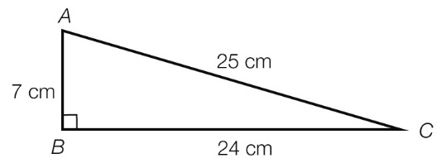

Question 10 4 marks [7.3]

|  |  |
| --- | --- |
| (a)  ACPM9_PR_7_09wsf | sin(θ) =  sin(34°) =  *x* = 5.2 × sin(34°)  *x* = 2.9 m (1 d.p.) |
| **(b)**  ACPM9_PR_7_10wsf | tan(θ) =  tan(27°) =  *b* =  *b* = 21.2 m (1 d.p.) |

Question 11 4 marks [7.4]

|  |  |
| --- | --- |
| (a) sin(θ) =  θ =  θ = 52° | (b) tan(θ) =  θ =  θ = 57° |

Question 12 2 marks [7.3]

tan(52°) = 

*d* = 

*d* = 4.9 m (1 d.p.)

Question 13 3 marks [7.5]

|  |  |
| --- | --- |
| (a)  ACPM9_PR_7_11wsf | (b) tan(38°) =  *h* = 150 × tan(38°)  *h* = 117.2 m (1 d.p.) |

Short answer total marks: 22

Extended answer section

Question 14 6 marks [7.5]

(a) sin(θ) = 

sin(θ) = 

*h* = 11 × sin(62°)

*h* = 9.71 m

(b) cos(θ) = 

cos(62°) = 

*x* = 11 × cos(62°)

*x* = 5.16 m

(c) cos(θ) = 

cos(θ) = 



θ = 28° (180° – 90° – 62° = 28°)

The ladder is making an angle of 28° with the building.

Question 15 6 marks [7.5]

**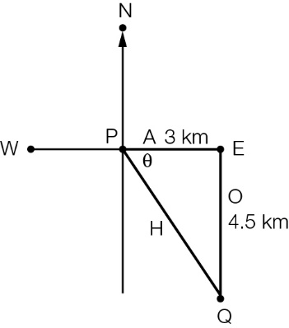**

**(a) (i)** tan(θ) = 

tan(θ) = 

θ = tan–1

θ = 56°

**(ii)** true bearing of *Q* from *P* = 90° + 56° = 146°T

**(b)** **(i)** Answer can be calculated using trigonometry or Pythagoras’ theorem.

Pythagoras’ theorem:

*c*2 = *a*2 + *b*2

*c*2 = 32 + 4.52

*c*2 = 29.25

*c* = 5.4 km (1 d.p.)

Trigonometry:

sin(56°) = 

H = 

H = 5.4 km (1 d.p.)

**(ii)** Total distance walked = 5.4 + 4.5 + 3 km

= 12.9 km

Extended answer total marks: 12

TOTAL test marks: 40